VISVESVARAYA TECHNOLOGICAL UNIVERSITY,
BELGAUM, KARNATAKA

MINOR-PROJECT-I
REPORT ON
“HOSTEL MANAGEMENT SYSTEM”
Submitted in partial fulfillment of the requirement for the award of the degree of
BACHELOR OF ENGINEERING
IN
COMPUTER SCIENCE AND ENGINEERING

Submitted by
Sl.No | USN | NAME
1. | 2SD22CS130 | POOJA S DODDAGOUDAR
2. | 2SD23CS400 | AMBIKA T CHAVAN
3. | 2SD23CS407 | PUNARVASU SHETAKE
4. | 2SD23CS409 | SMITAL S KAGINKAR

Under the Guidance of
Prof. Yashodha Sambrani
Dept. of CSE, SDMCET, Dharwad

DEPARTMENT OF COMPUTER SCIENCE AND ENGINEERING
S.D.M. COLLEGE OF ENGINEERING & TECHNOLOGY,
DHARWAD-580002
2024-25
ABSTRACT

The Hostel Management System (HMS) is a comprehensive software solution designed to streamline and automate the administrative tasks of hostel operations. This project addresses inefficiencies inherent in manual management methods by providing a web-based platform for room allocation, attendance tracking, leave request processing, Complaint and notifications. Built using contemporary web technology for the backend, and MongoDB for data storage, the system ensures scalability, reliability, and ease of use.
The HMS adopts a modular approach, incorporating features such as a user authentication system, automated room assignment, and leave letter generation. The inclusion of real-time notifications enhances communication between administrators and students, fostering a responsive management environment. The system emphasizes security with data encryption and user authentication measures, ensuring data privacy and integrity. Employing Agile development methodologies the project achieves iterative development, continuous integration, and deployment. This robust and user-friendly solution reduces administrative workload, minimizes human errors, and delivers a seamless user experience for both hostel staff and residents. Future enhancements may include integrating IoT for smart hostel management and extending support for multi-campus environments.

Table of Contents

PROBLEM STATEMENT 4
CHAPTER 1: INTRODUCTION................................................................................................................................. 5
CHAPTER 2: LITERATURE SURVEY 6
CHAPTER 3: DETAILED DESIGN 8
CHAPTER 4: PROJECT SPECIFIC REQUIREMENTS 11
CHAPTER 5: IMPLEMENTATION 16
CHAPTER 6: RESULTS 18
CHAPTER 7: CONCLUSION AND FUTURE SCOPE 22
REFERENCES 23

PROBLEM STATEMENT

“Towards Digital Hostel Administration: A Modular Web Application Approach”

CHAPTER 1: INTRODUCTION

A hostel management system is designed to simplify and automate the various administrative tasks involved in running a hostel. The daily operations of hostel administration are intended to be streamlined and automated by the “Hostel Management System”.
Conventionally hostel administration procedures involves manually handling tasks such as room allocation, attendance tracking, leave requests, Complaint , and Notification all of which are prone to errors and inefficiencies. Key features, including room assignment, leave letter processing, and attendance monitoring,Complaint , and Notificationare all integrated into one web-platform by this system. The project is to give both hostel management and students a more effective and user-friendly experience by utilizing contemporary web technologies.
The project's scope includes all important facets of hostel management with creation of a user-friendly home page. By automating repetitive processes like room assignments and attendance reporting, the system will meet the needs of hostel administrators. Easy access to features like checking room availability and filing leave requests will be beneficial to students. Thus, a digital solution offers a centralized platform where administrators can manage these operations more efficiently, reducing paperwork and human error while improving communication between hostel staff and students.

OBJECTIVES

To Enable students to apply for and manage leave requests seamlessly.

To Implement attendance tracking system that captures student attendance.

To Automate the process of allocating rooms to students based on various criteria, such as preferences, gender, and room availability.

To Generate reports for the various metrics.

To provide timely and efficient notifications for improved communication.

Handles student complaints and ensures timely resolution by hostel staff.

CHAPTER 2: LITERATURE SURVEY

S.No | Title & Author | Publication Details | Methodology | Limitations
1. | Hostel Management System  Authors:Prof M.Gudadhe, Ankit Bhoyar, Ashwin Karwade, Vinod Dhaware | International Research Journal of Modernization inEngineering Technology and Science, June 2022 | Developed a web application to manage hostel activities, integrating functionalities like room allocation, mess billing, and complaint registration. | Limitedscalability for institutions with large datasets or complex requirements.
2. | Development of an E-Based Hostel Management System  Authors: Akorede M. Diyaolu, Omolara B. Abodunrin, Abdullateef A. Adedamola, Rotimi S. Ogunode | International Journal of Innovative Science and Research Technology, June 2024 | Designed an electronic hostel management system to automate processes like student registration, room allocation, and fee payment. Focused on replacing manual record-keeping for efficiency and reliability. | System may face challenges with real-time data synchronization in multi-campus setups.
3. | Web-Based Hostel Management System for Improving Sustainable Performance of Educational Institutions  Authors: Bharamagoudar et al. | International Journal of Latest Trends in Engineering and Technology, Vol.(10)Issue(1), pp.050-053 | Developed a hostel administration portal using HTML and JavaScript. Facilitated room allocation, student Mess Payment calculation,Attendance entry Module | Limited by basic programming tools; lacks robust database support for complex data queries.
4. | Hostel Management System  Authors: Harsha V, Rohan J H, Deepak K R | International Journal of Advanced Research in Science, Communication and Technology (IJARSCT), Volume 2, Issue 1, August 2022 | Developed a computerized hostel management system to automate manual hostel operations. The study reviewed existing systems to identify inefficiencies and designed a solution with features like room allocation, attendance. | Limited customization for specific institutional needs; may require additional modules for integration with existing campus systems.

Key Observations:
- Technologies Used: Studies employ various tools, such as cloud-based systems, HTML, JavaScript, and database integration, to enhance system functionality.
- Limitations: Common challenges include scalability for large institutions, integration with existing ERP systems, and risks associated with cloud-based solutions.

CHAPTER 3: DETAILED DESIGN.

SYSTEM ARCHITECTURE OF HMS
Fig1. System Architecture

ENTITY - RELATIONSHIP MODEL

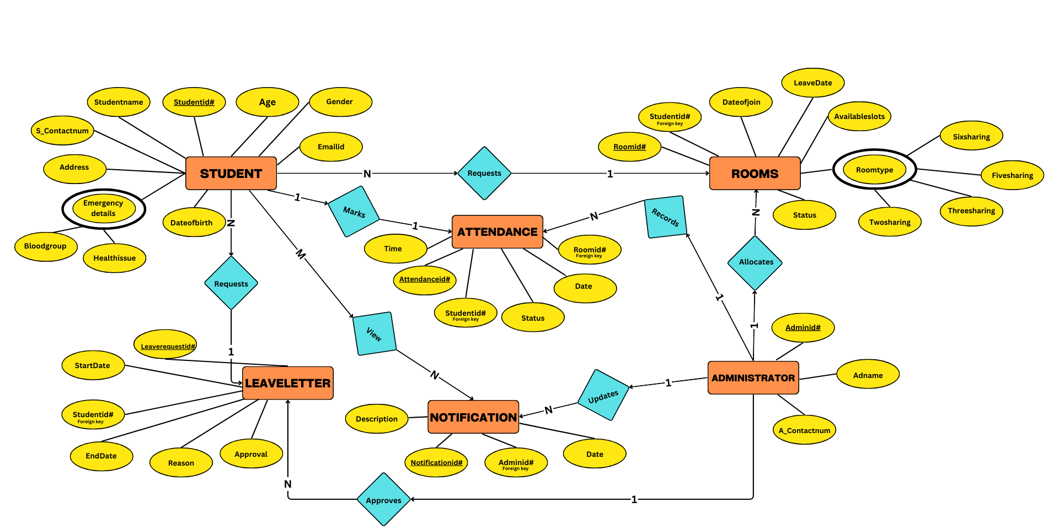
Fig 2. ER Model
USE CASE DIAGRAM
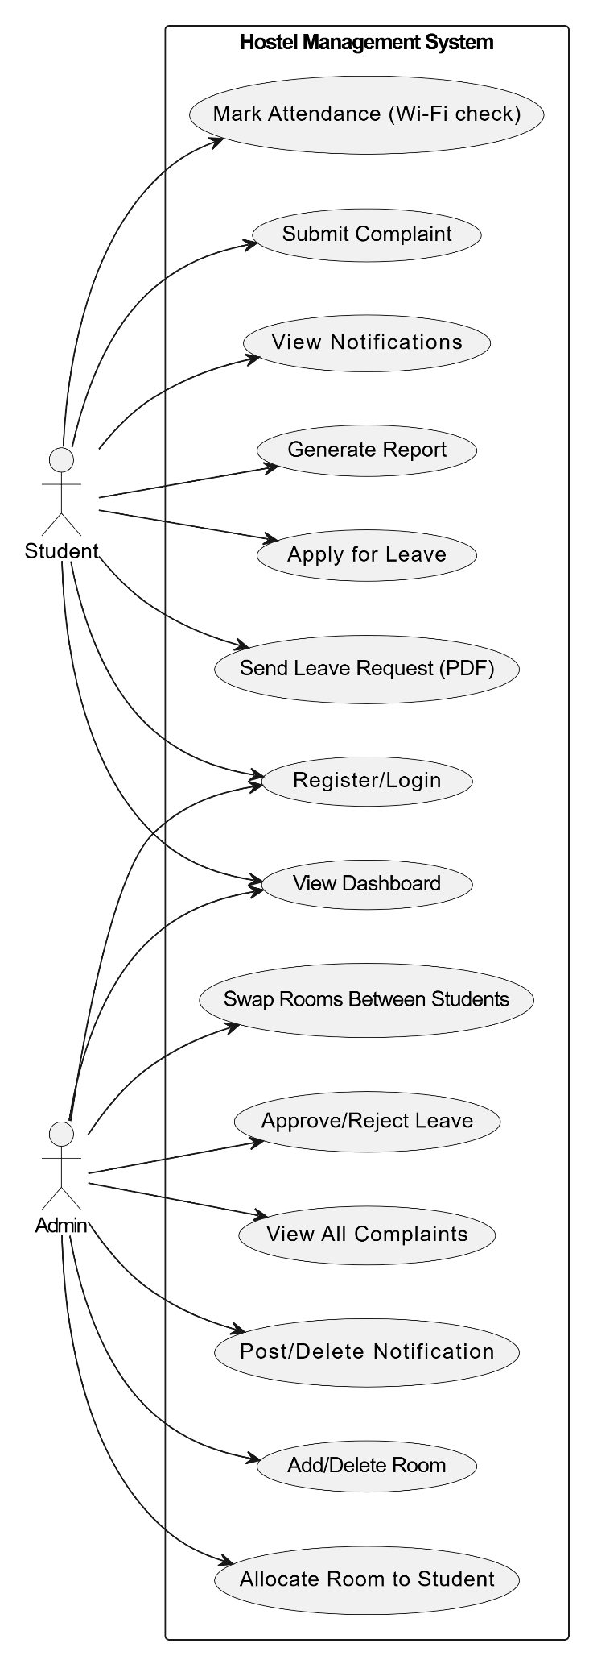

Fig 3. Use Case Diagram
ACTIVITY DIAGRAM
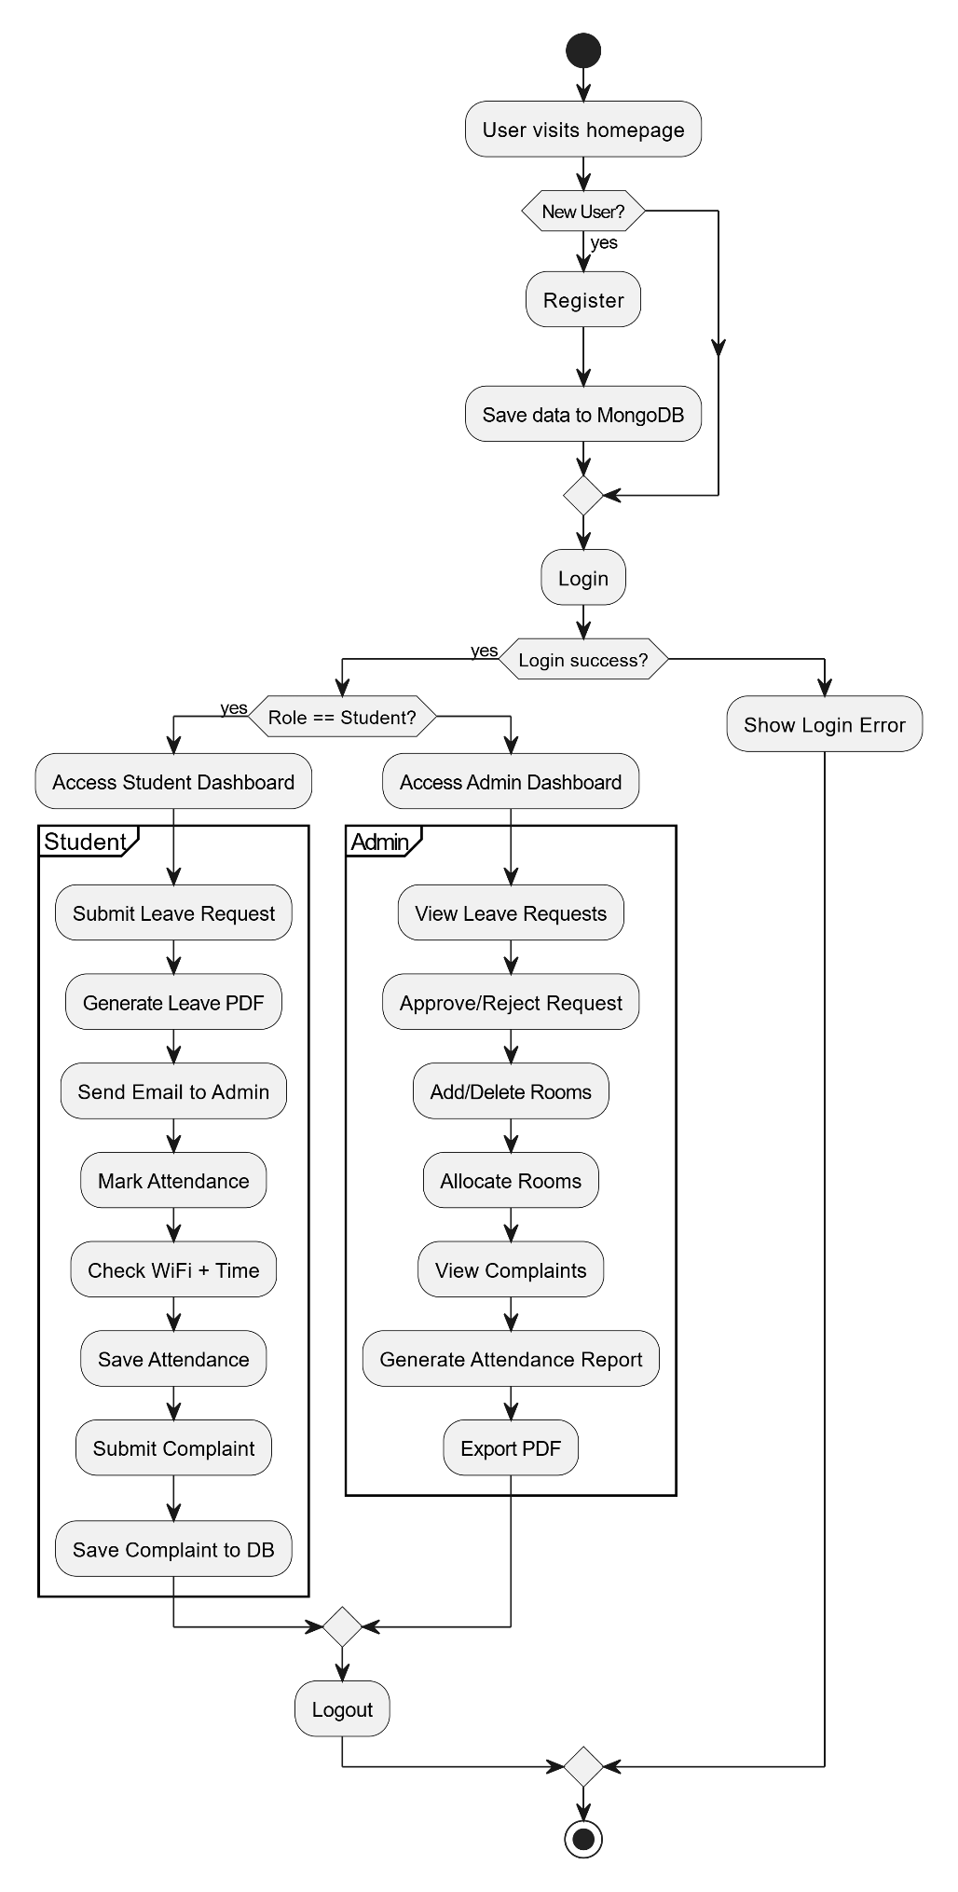
Fig 4. Activity Diagram

CLASS DIAGRAM
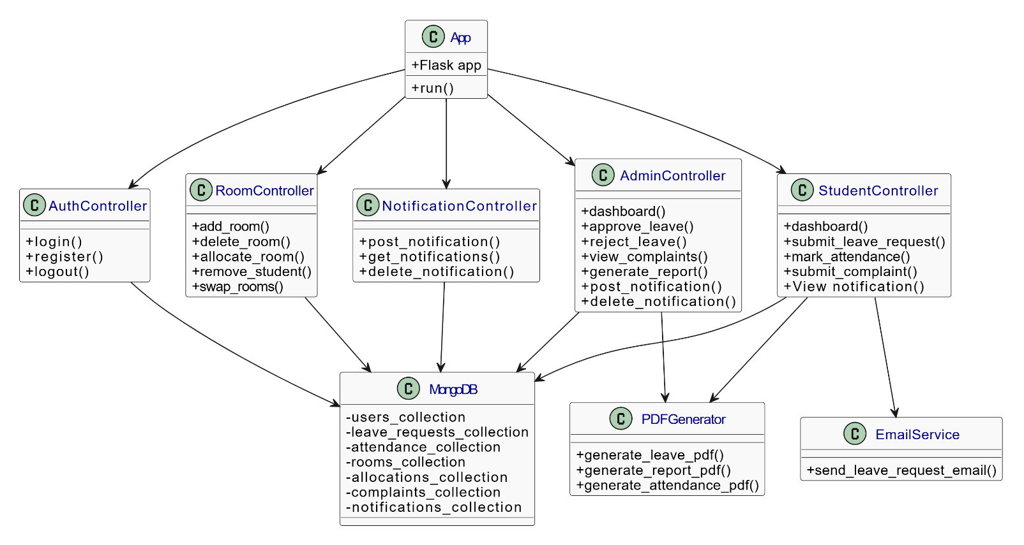
Fig 5. Class Diagram

SEQUENCE DIAGRAM
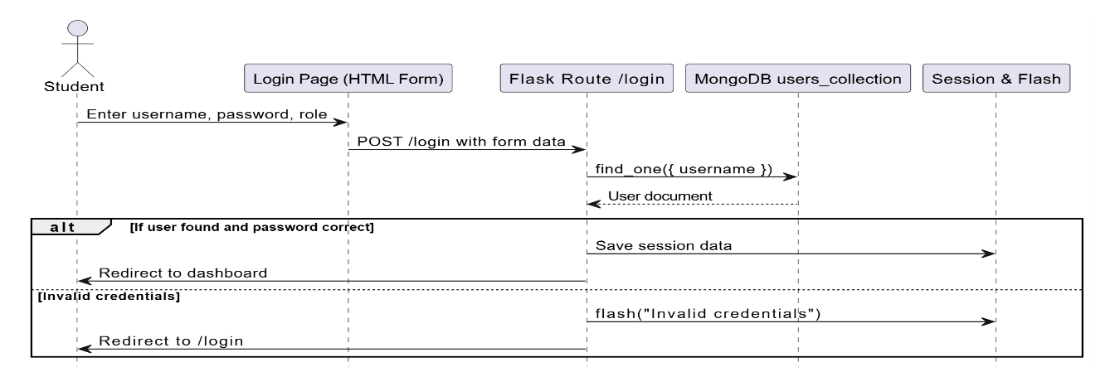
Fig 6. Login Page
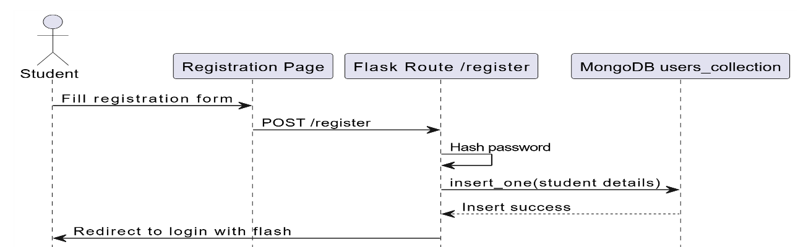
Fig 7. Registration Page

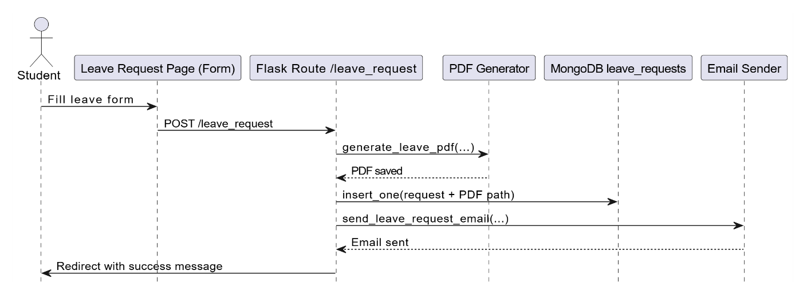
Fig 8. Leave Request Page

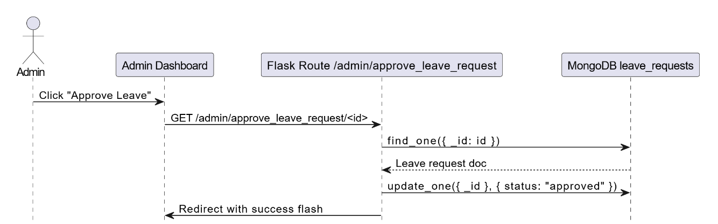

Fig 9. Admin Dashboard
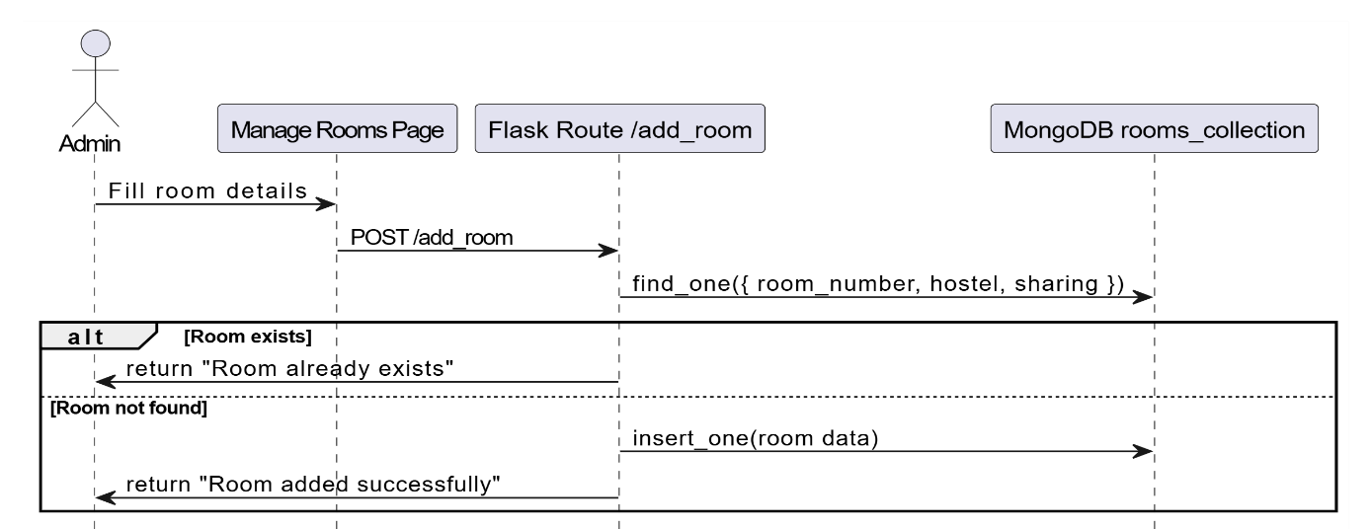

Fig 10. Manage Room Page(Add Room)

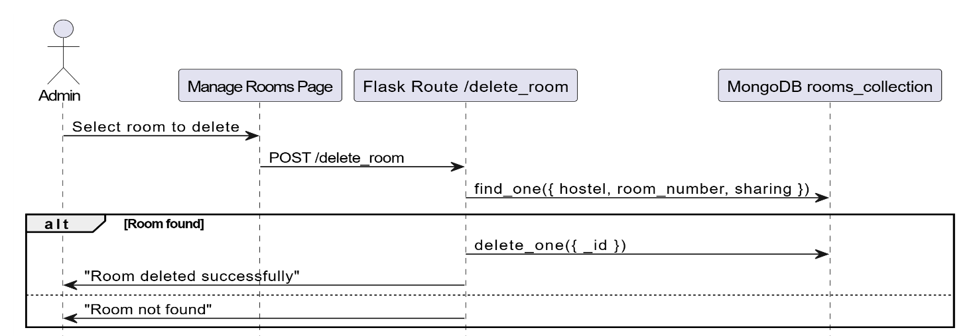
Fig 11. Manage Room Page(Delete Room)

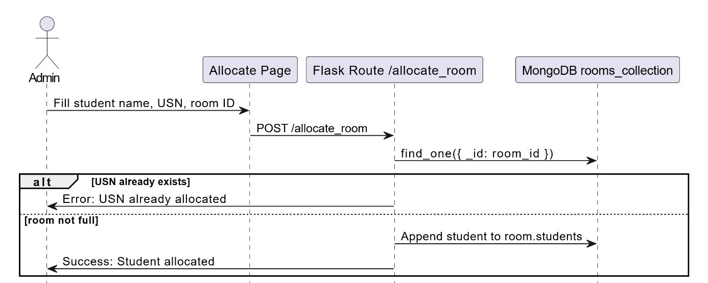
Fig 11. Manage Room Page(Allocate Room)

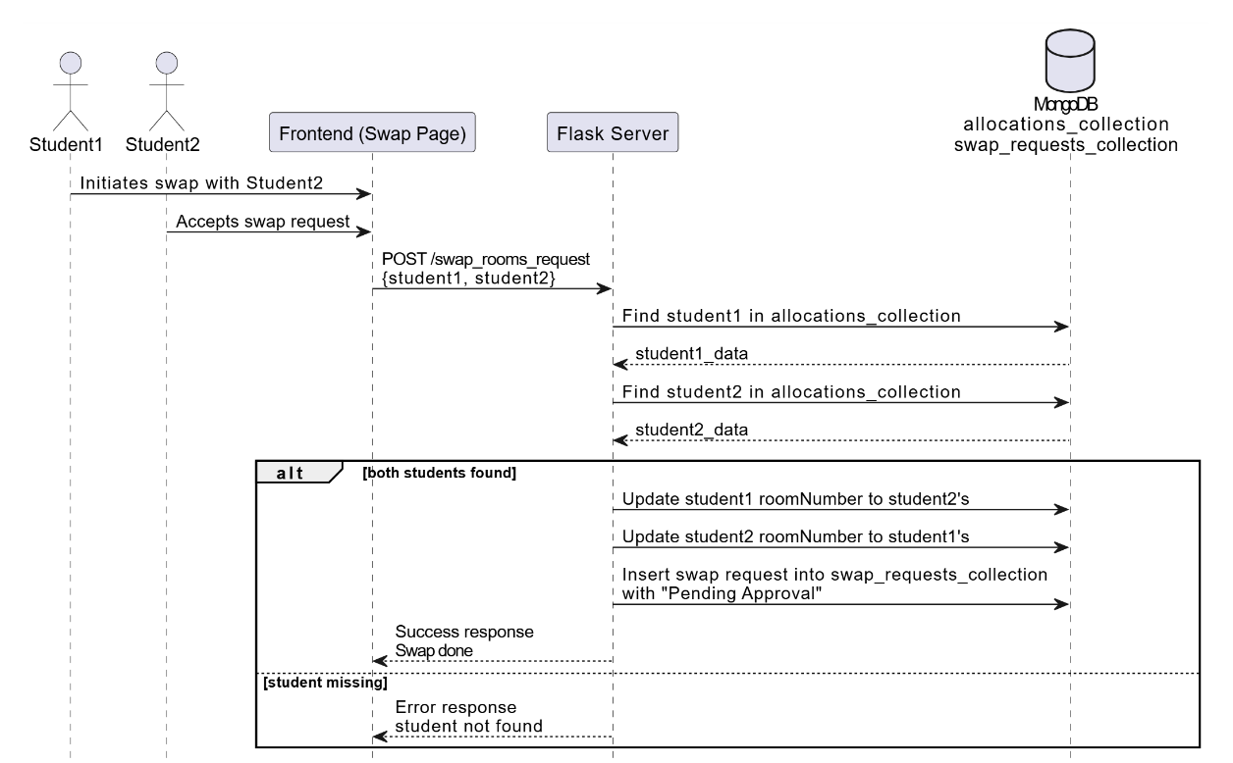

Fig 12. Manage Room Page(Swap_Room_Request)
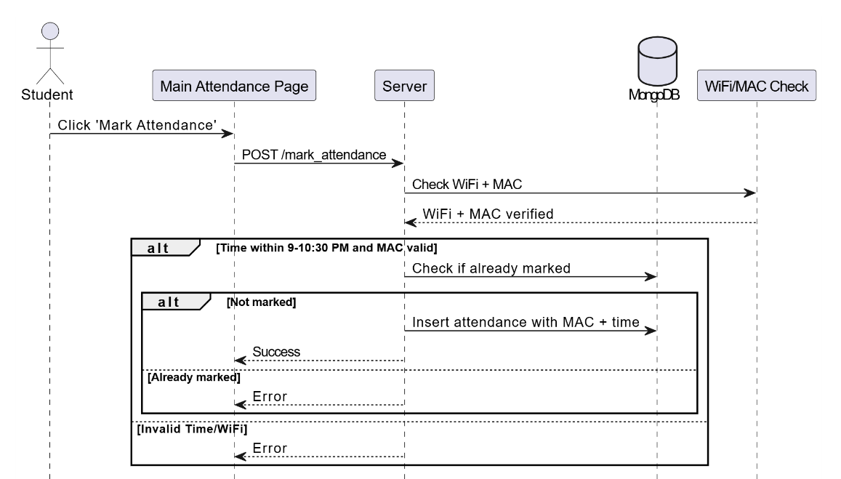
Fig 13. Main Attendance Page

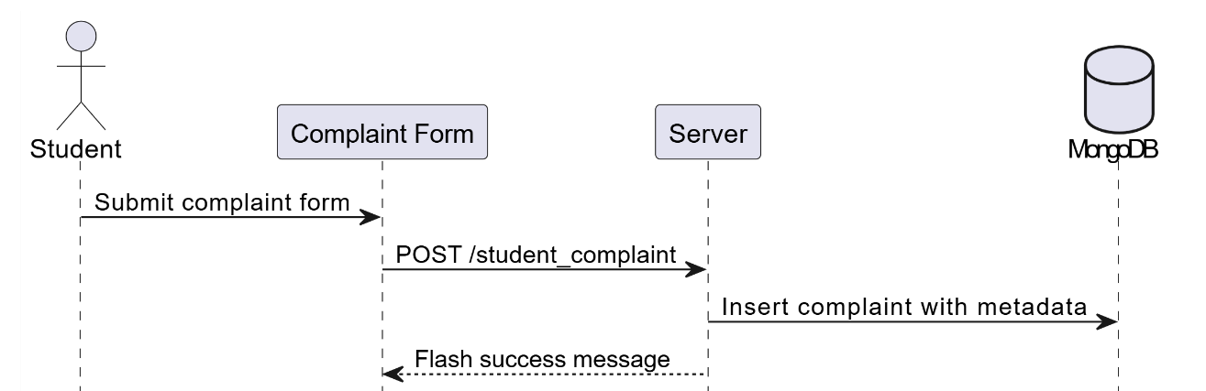
Fig 14. Complaint Form

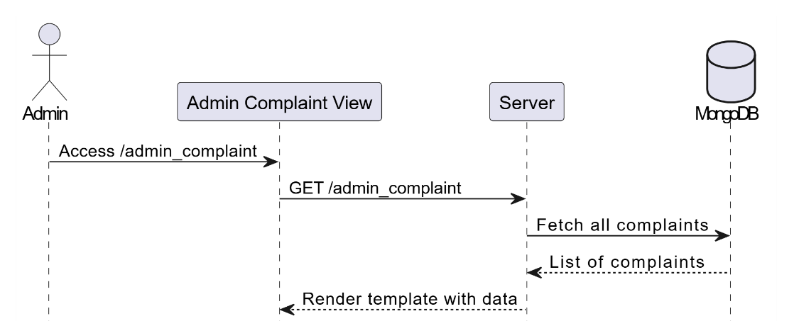
Fig 15. Admin Complaint View

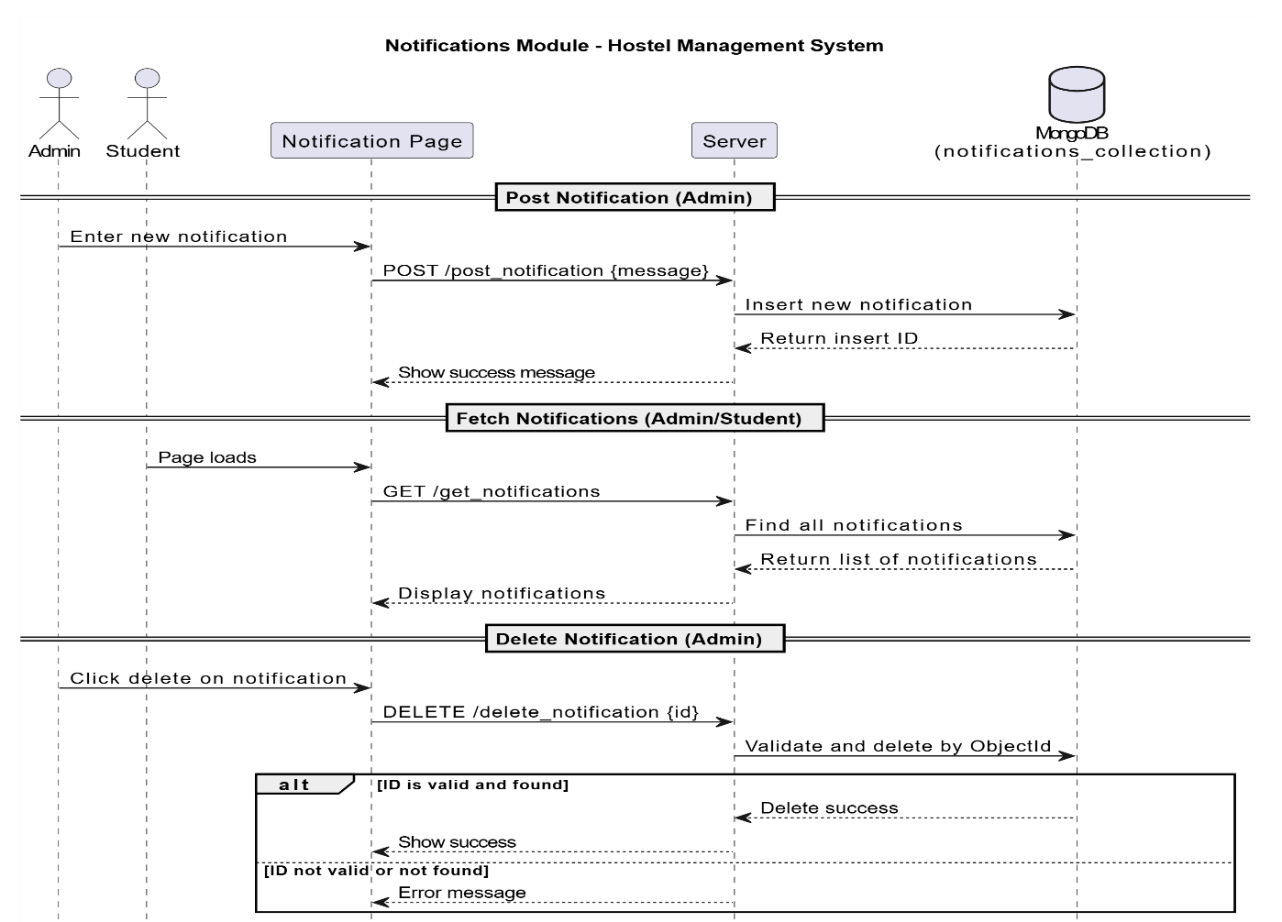
Fig 16. Notification Page

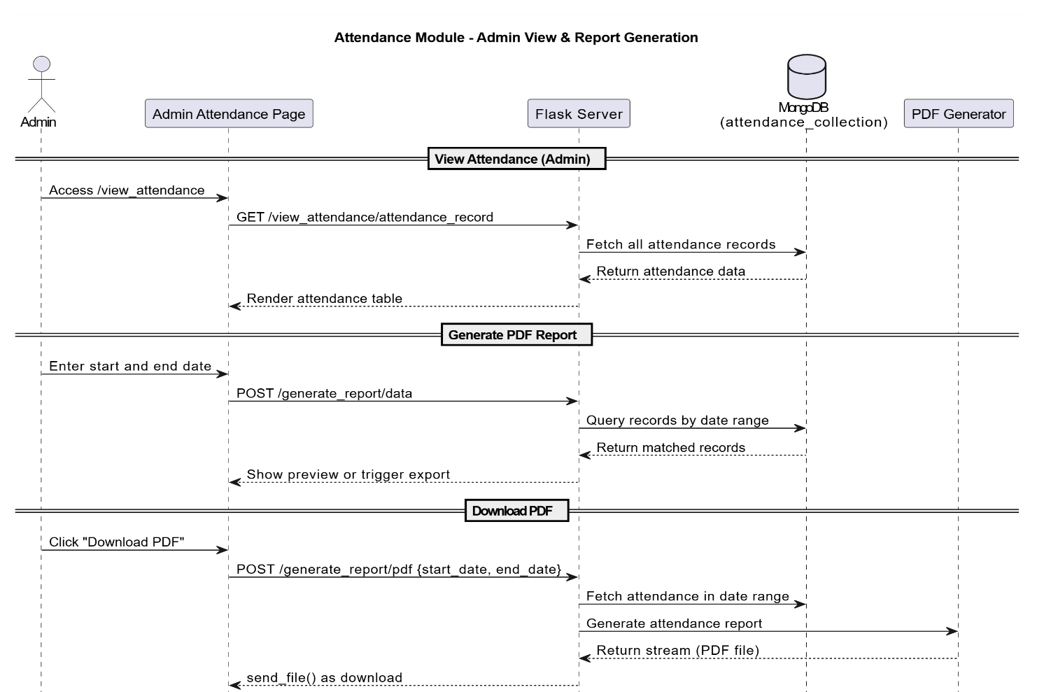
Fig 17. Admin Attendance Page

CHAPTER 4: PROJECT SPECIFIC REQUIREMENTS

A Hostel Management System (HMS) that specifically involves generating leave letters, room allocation, Attendance Monitoring, a main login page,Complaint and notifications, there are several critical project-specific requirements.
System components:
- Functional Requirements:
- Main Login Page (Authentication and Authorization)
- Functional Requirement:
- User Roles: The main login page should authenticate multiple user roles such as Admin and Student Each role has different access levels and functionalities.
- Admin: Full access to manage all features of the hostel management system (students, rooms, leave requests, reports,notifications).
- Student: Limited access to their personal data, room allocation, leave request, view notifications.
- Features and Design:
- Login Screen: Users should input their credentials (username and password).
- Password Recovery: Include an option for users to reset their passwords.
- User Interface: A clean, simple, and secure login page that should be responsive.

- Room Allocation Module
  - Functional Requirement:
Room Management: This module allows for the management of room availability, assignment, and the process of booking rooms for students.
- Room Availability: Admins can update the availability status (e.g., booked, vacant, under maintenance).
- Room Preferences: Students can choose room types (e.g., single, double, shared, etc..).
- Automatic Allocation: This system automatically allocate rooms based on availability.
  - Features and Design:
- Student Registration: A student can select their room preferences during registrationand the system will match them to the available rooms.
- Search and Filter: Admins should be able to search for available rooms, view details about each room, and assign rooms to students.
- Room Details: Each room should include detailed information (e.g., room number, room type).

- Leave Letter Generation and Leave Management
  - Functional Requirement:
Leave Request: Students can request leave from the hostel for a specific duration, and they must specify the reason for the leave.
- Leave Types: Students may request different types of leave (e.g., personal, emergency).
- Leave Approval: Admins must approve or reject leave requests.
- Leave Letter Generation: Once leave is approved, the system should generate an official leave letter with details such as the student’s name, room number, leave dates, and reason.
  - Features and Design:
  - Leave Application: A form where students enter leave dates and reasons for absence.
  - Leave Status: Students can view their leave request status (approved, rejected, pending).
  - Leave Letter Generation: Automatically generate and download a leave letter in a printable format (e.g., PDF). The letter should include:
- Student Name
- Room Number
- Date of Leave
- Approval Status of admin

- Notification System
  - Functional Requirement:
Notifications: The system should send notifications to users (students and admins) based on specific events like room allocation, leave approval, and more.
- In-App Notifications: Notifying users via the dashboard about relevant updates or changes (e.g., new leave requests, room changes, etc.).
  - Features and Design:
      - Real-Time Notifications: Implement real-time notifications for immediate updates, such as when a student’s leave request is approved or when room status changes.
      - Notification Types: Different types of notifications should be available for different roles:
- Admin: Receive notifications about leave requests, room assignments, complaints.
- Students: Receive notifications for room allocation, leave status.

- Attendance Monitoring
  - Functional Requirement:
- Time-Constrained Marking: Students must mark attendance within a specific time window; late entries are not accepted.
- Wi-Fi-Based Verification: Attendance is recorded only if the student is connected to the designated hostel Wi-Fi network.
- Daily Attendance: Students mark their presence daily through the system.
- Admin Oversight: Admins can view and manage daily attendance logs.
- Report Generation: Admins can download monthly/weekly attendance reports.
  - Features and Design:
- Attendance Form: Students can mark attendance via a secure form available only during allowed hours.
- Network Constraint Check: System validates student’s Wi-Fi connection before recording attendance.
- Export Reports: Admins can filter, view, and export attendance records in PDF format.
- Complaint Module
  - Functional Requirement:
- Complaint Submission: Students can submit complaints related to hostel facilities, services, or issues (e.g., maintenance, food, internet).
- Admin Review: Admins can view submitted complaints,update their status.
- Notifications: Students are notified via system alerts when the complaint status is updated by the admin.
  - Features and Design:
- Complaint Form: A simple form for students to describe their issue.

- Non - Functional Requirements:
- Usability
- The system has an intuitive, user-friendly interface that is easy for users to navigate.
- The design is responsive to support different screen sizes (desktop, tablet, mobile).
- Performance
- This system load quickly and handle a large number of users without performance degradation.
- Room allocation and leave requests should be processed efficiently to ensure minimal delay.
- Security
  - Encrypt sensitive data (e.g., student details) to protect user privacy.
  - Implement secure login mechanisms (e.g.,HTTPS, multi-factor authentication).
  - Reliability and Availability
Ensures high availability with minimal downtime. This system be fault-tolerant and capable of handling errors gracefully (e.g., room allocation failures, leave request issues).
  - Maintainability
This system should be easy to maintain, with clean and modular code. Regular updates, bug fixes, and enhancements should be easy to implement without disrupting the user experience.

- Supported Methodologies:
Agile Methodology
Breakdown of Hostel Management System project using Agile methodology.
The system includesthefour modules: Login, Leave Management, Attendance Tracking, Room Allocation, and Notification System.

  - Epic
Hostel Management System
The epic focuses on streamlining hostel management by creating a system where admins and students interact efficiently through various modules.

Modules as User Stories and Tasks
- Module 1: Login System
User Story: Admin and Student Login
Admin/studentcan log in usingusername and password so that they can access the dashboard.
Tasks:
- Create a secure login page for admins and students.
- Validate login credentials.
- Redirect to the main dashboard upon successful login.

- Module 2: Leave Management System
User Story1: Student Leave Request
A student can submit a leave request so that the admin can review and approve/reject it.
Tasks:
- Build a form for students to input leave details (dates, reason).
- Notify the admin of the new leave request.
- Display the status of leave requests on the student's dashboard.
User Story 2: Admin Leave Approval/Rejection
An admin can approve or reject leave requests so that the system reflects updated records.
Tasks:
- Create an admin interface to view all leave requests.
- Enable the admin to approve/reject requests with optional comments.
- Notify students of the decision via the dashboard.

- Module 3: Attendance Tracking System
User Story 1: Automated Attendance Management
An admin can mark attendance automatically based on room allocation and constraints (e.g., zones, time) so that it reduces manual effort.
Tasks:
- Develop an attendance tracker linked to room allocation data.
- Implement filters for constraints like dates, time, and areas.
- Generate attendance reports for admin use.

User Story 2: Student Attendance View
Astudent can view attendance record so that they track their attendance.
Tasks:
- Display attendance records on the student's dashboard.
- Allow filtering based on time periods.

- Module 4: Room Allocation System
User Story 1: Student Room Request
Astudent can request a room so that I can be accommodated as per my needs.
Tasks:
- Provide a room request form with options like preferred room type and roommates.
- Notify the admin of the request.
User Story 2: Admin Room Allocation
An admin can allocate rooms to students so that the system reflects the assignments.
Tasks:
- Develop a dynamic room allocation feature that considers availability and preferences.
- Notify students of their assigned rooms.
User Story 3: Room Swapping
A student can request room swaps with other students so that they can adjust according to their convenience.
Tasks:
- Build a request system for room swaps.
- Notify both students and the admin about swap requests.
- Allow admin to approve/reject swap requests.

- Module 5: Notification System
User Story 1: Admin Notifications
An admin can send notifications to students so that they are informed about important updates.
Tasks:
- Create an interface for sending notifications.
- Notifications should appear prominently on the student dashboard.
User Story 2: Student View Notifications
Astudent can view notifications on the dashboard so that they stay updated.
Tasks:
- Display a list of notifications on the student's dashboard.
- Highlight unread or urgent notifications.

- Module 6: Complaint Module
User Story 1: Student Submits Complaint
A student can submit a complaint about hostel-related issues so that it can be addressed by the admin.

Tasks:
- Design a complaint submission tab with fields for category, description.
User Story 2: Admin Complaints
Astudent can view notifications on the dashboard so that they stay updated.

CHAPTER 5: IMPLEMENTATION

Tools and Technologies:
- Frontend:HTML, CSS, React JS, JavaScript –used for building a responsive web application

- Backend:Uses a backend framework likepythonto manage the business logic and database interaction.
- Flask: For requesting APIs.
- werkzeug.security: It generates passwords in hash format for security.
- reportlab: It helps in generating a leave letter importing from canva.
- MIMEMulitipart:It helps in creating leave requests.
- Pymongo:It helps in database connectivity.

- Database: A non-relational database - MongoDB to store student data, room details, leave records, attendance, generating reports,etc.

Design Patterns:
Model-View-Controller (MVC): Uses this pattern to separate concerns between the data layer (Model), UI (View), and business logic (Controller).
1. Model (Data Management Layer)
The Model serves as the data management layer, handling data logic and database interactions. It defines entities such as Student, LeaveRequest, Complaint, Room, Attendance, Notification, and RoomSwapRequest. These models represent core functionalities like student registration, leave application, room allocation, complaints, and attendance tracking. For example, the Student model stores personal details, credentials, room and attendance status; LeaveRequest handles application details; Room manages room types, availability, and allocation; while Complaint and Notification manage student grievances and admin communications respectively. The system uses MongoDB as the non-relational database and PyMongo to interface it with Flask. Sensitive information like passwords is secured using werkzeug.security, ensuring secure handling of data.linking them
.
2. View (Presentation Layer)
The View is the presentation layer and is responsible for rendering the user interface. It comprises various web pages and interactive components built with React.js, HTML, CSS, and Bootstrap. The student-facing views include pages like Login, Registration, Student Dashboard, Leave Request, Complaint Page, Attendance View, and Room Swap Request. For the admin, views such as the Admin Dashboard, Room Allocation Page, and Notification Page are provided to manage operations efficiently. The visual layout is clean and responsive, providing students and admins an intuitive interface. Additionally, tools like ReportLab are used to generate printable leave letters in PDF format.
3. Controller (Business Logic Layer)
The Controller represents the application logic and serves as the link between the Model and the View. It handles all incoming HTTP requests, processes user input, performs business logic, and communicates with the data layer to fetch or update information. Built using Flask, the controller manages routes such as /login, /submit_leave, /add_room, /complaint, and /swap_request. It ensures users are authenticated and authorized based on roles (Admin or Student) and facilitates key operations like room allocation, leave approval, complaint application, attendance logging, room swap handling, and notification broadcasting. The controller also ensures that responses are correctly rendered on the respective views and users receive real-time updates through their dashboards..

MVC pattern working in Hostel Management System:
- UserInteraction:The user accesses the homepage (/), and the View (leave_form.html) renders a leave request form.
- Submitting Form: When the form is submitted, the Controller (app.py) handles the data and interacts with the Model.
- Data Handling: The Model stores the student's leave request details in the database.
- Response: The Controller sends a confirmation message back to the View.

Key Features Implemented
- Student Management
    - Students can register, log in, and update personal details.
    - Admins can view, manage, and modify student records.
- Leave Management System
    - Students can submit leave requests specifying duration and reason.
    - Admins can approve or reject leave requests with comments.
    - Status updates are visible to students on their dashboards.
- Complaint Module
    - Students can raise complaints related to hostel issues.
    - Admins can view, manage, and update complaint statuses.
- Room Allocation System
    - Students can submit room requests with preferences.
    - Admins allocate rooms based on availability and preferences.
    - Room swap requests can be initiated and approved by the admin.
- Attendance Tracking System
    - Admins can automate attendance based on zones and timestamps.
    - Students can view their attendance history filtered by date/time.
- Notification System
    - Admins can send important updates and alerts to students.
    - Students view all notifications on their dashboard with unread indicators.
- Database Management
    - All data including students, rooms, leave, attendance, and complaints are securely stored in MongoDB.
    - Integrated using PyMongo for backend interaction.
.

CHAPTER 6: RESULT
- HOME PAGE
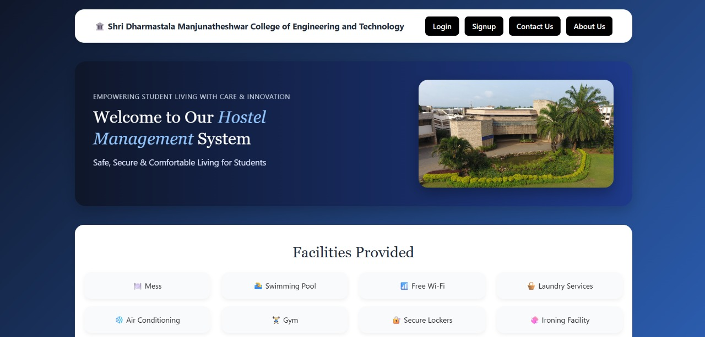
Fig1. Home Page
- LOGIN PAGE
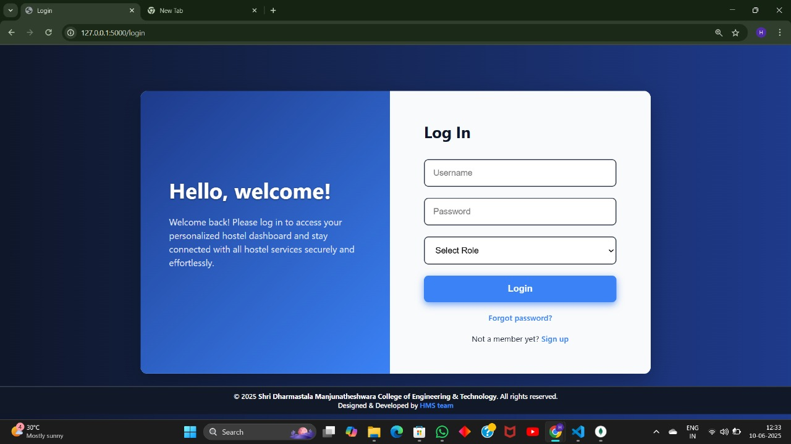
Fig2. Login Page
- ADMIN DASHBOARD
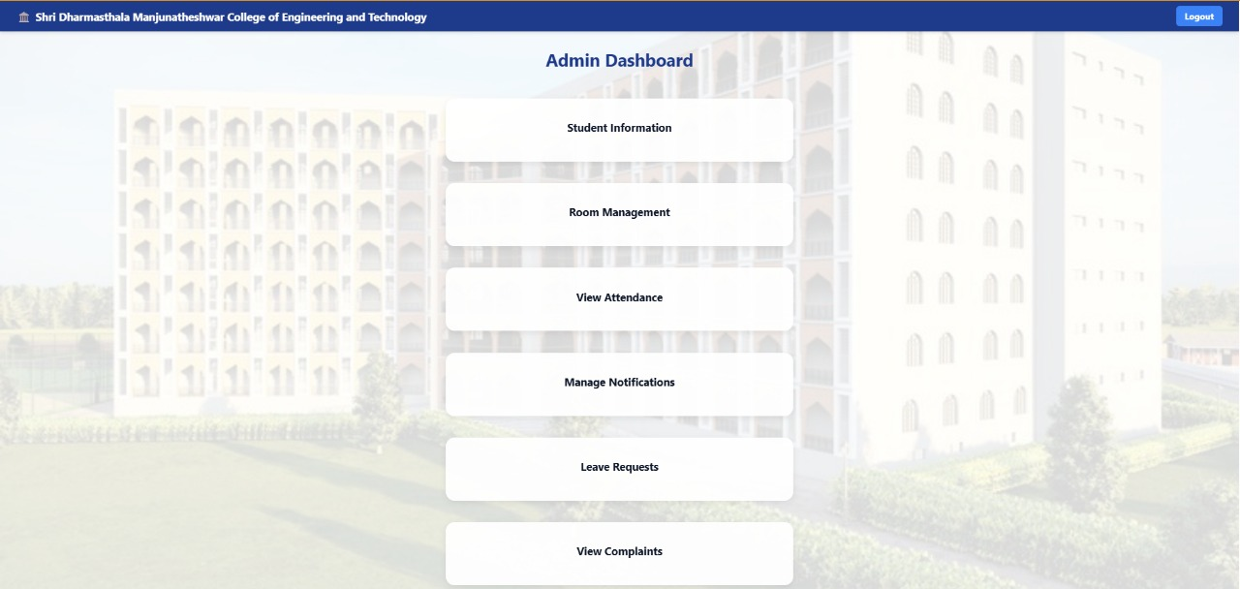
Fig3. Admin Dashboard
- STUDENT DASHBOARD
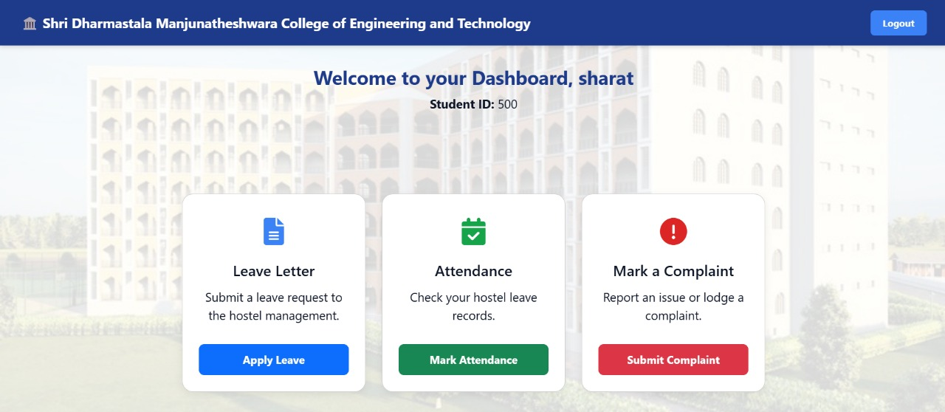
Fig4. Student Dashboard
- ROOM DASHBOARD
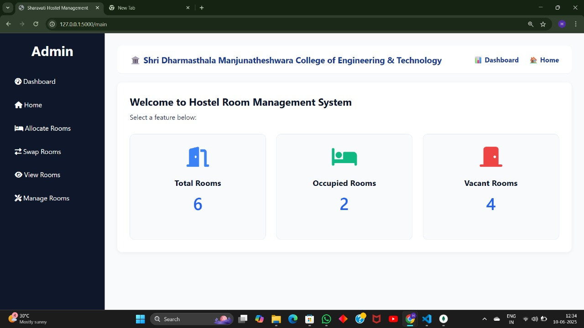
Fig5.Room Dashboard
- ADD ROOM PAGE[ADMIN]
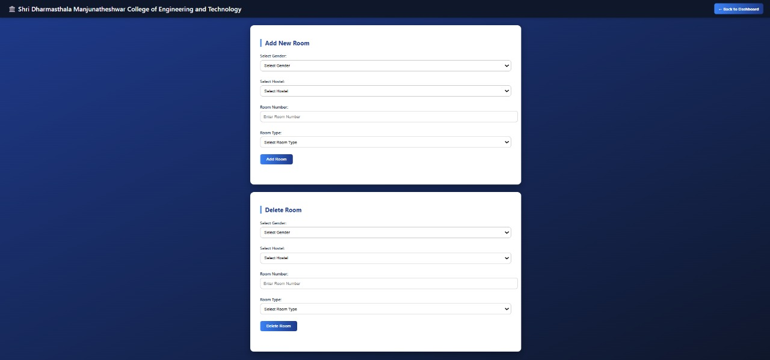
Fig6.Add Room Page[admin]

- STUDENT ATTENDANCE PAGE[STUDENT]
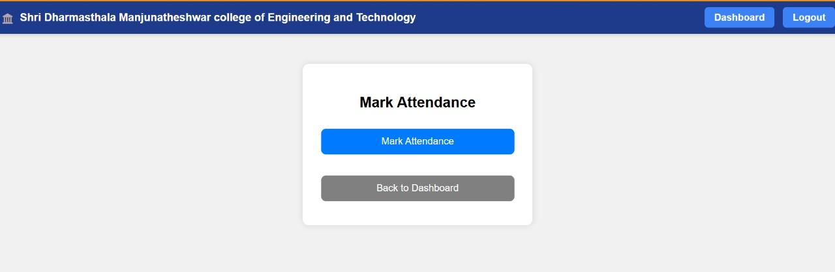
Fig7.Student Attendance Page[student]
- ROOM ALLOCATION PAGE[ADMIN]
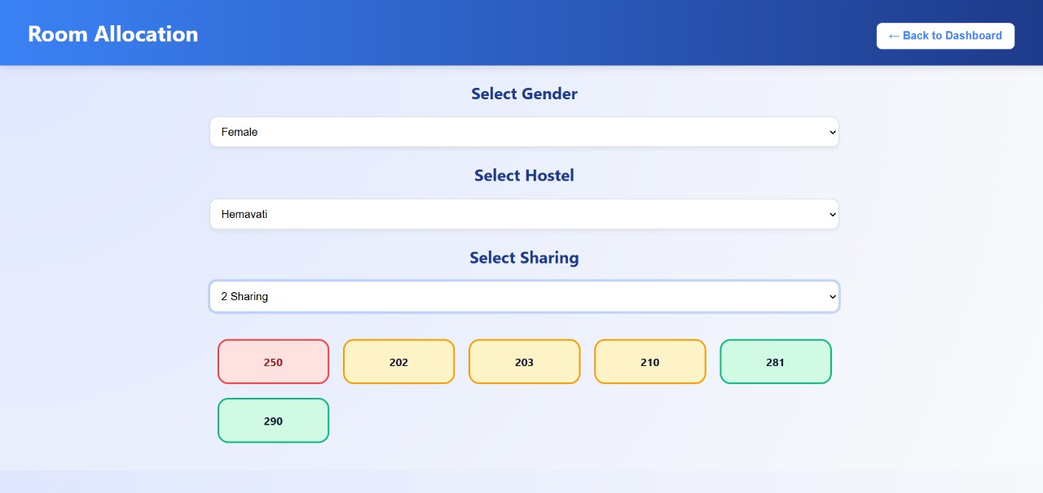
Fig8.Room Allocation Page[admin]
- COMPLAINT PAGE[STUDENT]
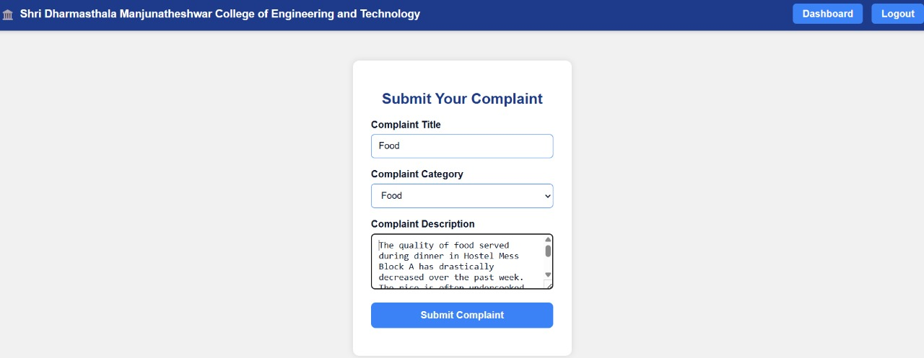
Fig9.Complaint Page[student]

- LEAVE REQUEST PAGE[STUDENT]
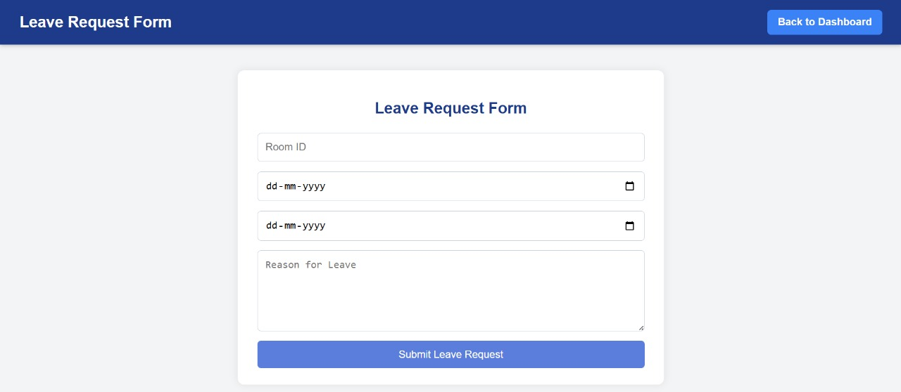
Fig7.Leave Request Page[student]
- NOTIFICATION PAGE[ADMIN]
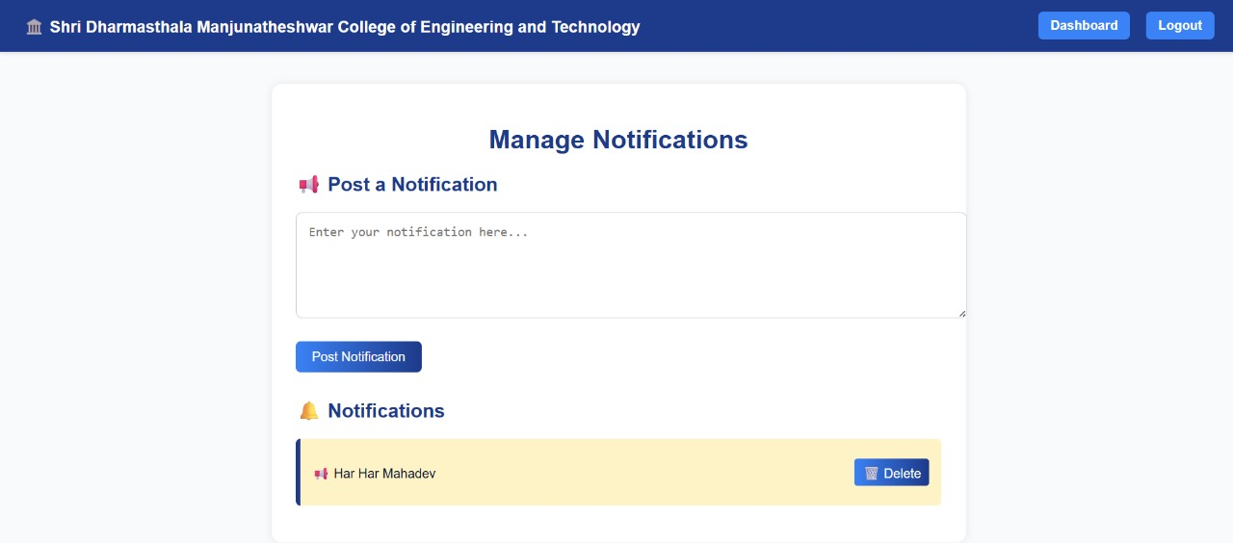
Fig10.Notification Page[admin]

- STUDENT DETAILS PAGE
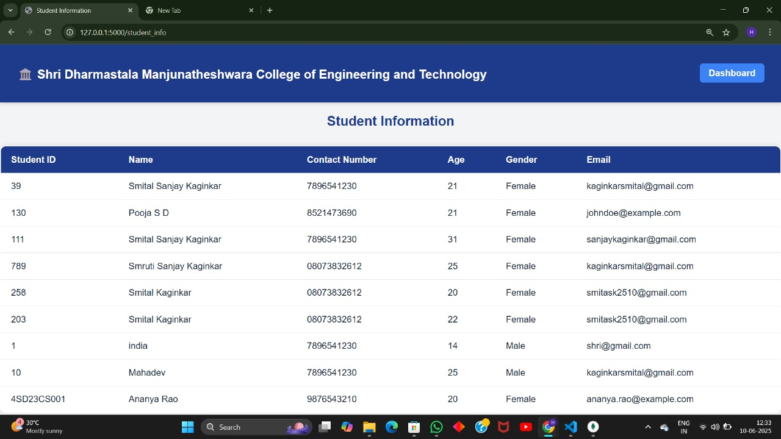
Fig11.Student Details Page

- STUDENT ATTENDANCE DETAILS PAGE
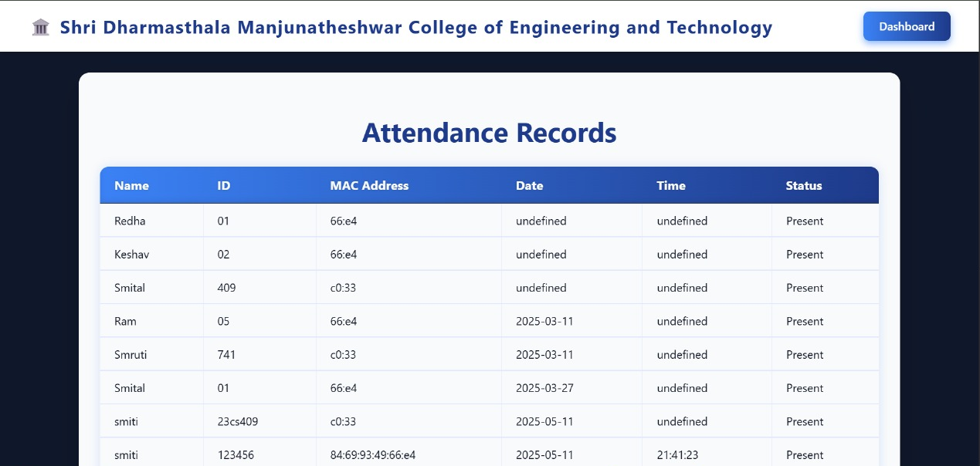
Fig12.Student Attendance Details Page

- .LEAVE REQUEST DETAILS PAGE
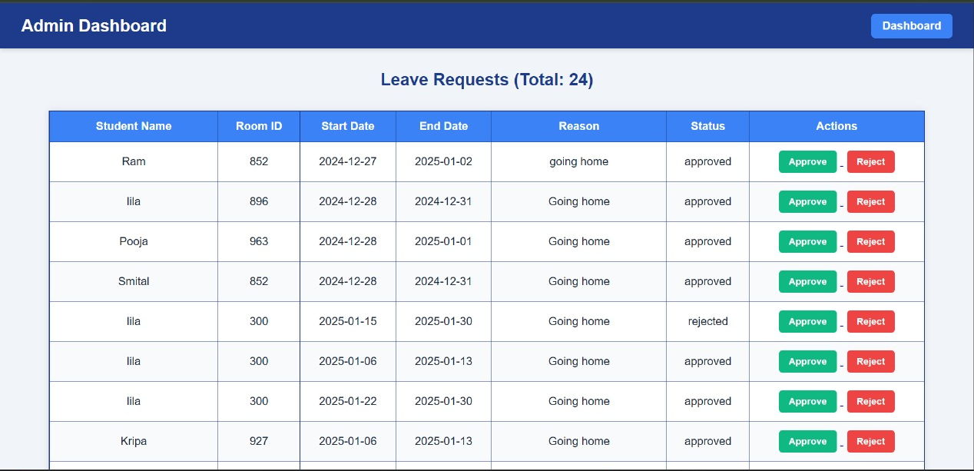
Fig13.Leave Request Details Page

CHAPTER 7: CONCLUSION

The Hostel Management System (HMS) is a comprehensive software solution designed to streamline and automate the administrative tasks of hostel operations. This project addresses inefficiencies inherent in manual management methods by providing a web-based platform for room allocation, attendance tracking, leave request processing, Complaint and notifications. Built using contemporary web technologies for the backend, and MongoDB for data storage, the system ensures scalability, reliability, and ease of use.
The HMS adopts a modular approach, incorporating features such as a user authentication system, automated room assignment, and leave letter generation. The inclusion of real-time notifications enhances communication between administrators and students, fostering a responsive management environment. The system emphasizes security with data encryption and user authentication measures, ensuring data privacy and integrity. Employing Agile development methodologies the project achieves iterative development, continuous integration, and deployment. This robust and user-friendly solution reduces administrative workload, minimizes human errors, and delivers a seamless user experience for both hostel staff and residents. Future enhancements may include integrating IoT for smart hostel management and extending support for multi-campus environments.

CHAPTER 8:FUTURE SCOPE
- Biometric or RFID Attendance Integration:
Implementing fingerprint or RFID systems for attendance would increase reliability and prevent misuse.
- Mobile Application Support:
Developing a mobile app version would enhance user accessibility and enable real-time notifications on the go.
- Advanced Analytics and Reporting:
Adding analytical dashboards and smart reports could help administrators track patterns in attendance, complaints, and room usage.
- Chatbot Integration:
A chatbot can assist users with common queries, leave status checks, and complaint updates.
- Multi-Institution Support:
The system can be expanded to manage hostels across multiple institutions within a single platform.
- Third-Party Service Integration:
Integrating with services like online fee payment, maintenance vendor systems, or meal tracking can provide a more holistic hostel management solution.
- Additional User Roles:
Future versions could include specific dashboards for wardens, maintenance staff, or security personnel for better task delegation.
- AI-Driven Room Allocation:
Implementing AI algorithms for room allocation could optimize assignments based on student preferences and historical data.

REFERENCES

[1] Bharamagoudar, S.R., Geeta, R.B., &Totad, S.G.
Web-Based Hostel Management System for Improving Sustainable Performance
of Educational Institutions.
International Journal of Latest Trends in Engineering and Technology,
Vol. 10, Issue 1, pp. 050-053, 2022.

[2]Diyaolu, A.M., Abodunrin, O.B., Adedamola, A.A., &Ogunode, R.S.
Development of an E-Based Hostel Management System.
International Journal of Innovative Science and Research Technology, June 2024.

[3] Gudadhe, M., Bhoyar, A., Karwade, A., &Dhaware, V.
Hostel Management System.
International Research Journal of Modernization in Engineering Technology and
Science, June 2022.

[4]Gupta, N., Kumar, R., & Pratiksha, D.
Automated Hostel Management System.
International Journal of Advanced Research in Computer and Communication
Engineering, February 2020.

[5]Harsha, V., Rohan, J.H., & Deepak, K.R.
Hostel Management System.
International Journal of Advanced Research in Science, Communication and
Technology (IJARSCT), Volume 2, Issue 1, August 2022.

